INSTRUCTION & OPERATING MANUAL FOR
1H AUTOMATIC SCREW CAP SEALING MACHINE

MODEL NO: VASCS-60

IPO NO:
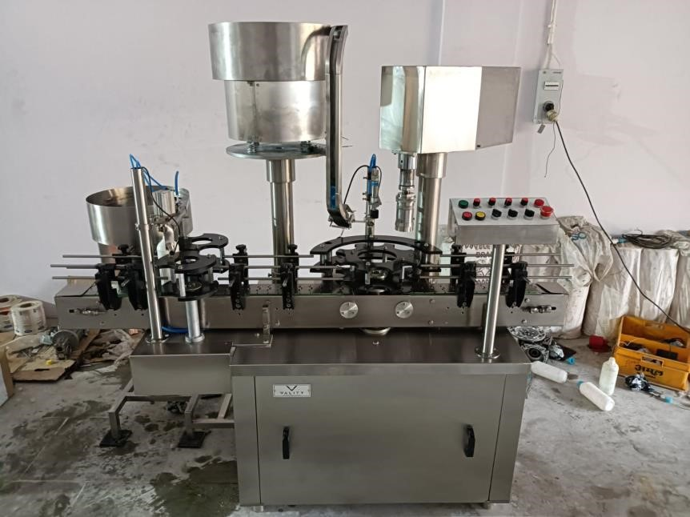

OFFICE & WORKS:

B N ENTERPRISES
Gate No.20,Near Khedshivapur
Industrial Estate, Kondhanpur Road, Arvi Village,Pune-412205(MH)India.
Mob No – 8308746511/9607993690
E mail : inf.bnenterprises@gmail.com URL : www.bnenterprises.net

Safety Precaution for Accident Prevention

- The Machine and equipment of B N ENTERPRISES provided at the manufacturing works in accordance with current standards of engineering, and in compliance with regulation for the prevention of an accident, consideration have been given to the application for which the machine was designed.

- The operation of the machine is expected to observe the regulations started below with a view to achieving maximum safe working of the machine.

- When carrying out overhead, setup inspection and maintenance work, always put the drive motor out of action by mean of a switch which isolated all the poles and can be locked and which or in the desk or control panel of the plant the more removal of the fuses is inadequate.
- If the machine is put of action by actuation the emergency stop switch, it must not restart when the switch safety devices is reset. The machine must not start before the master switch is turn on again.
- If the employees of a plant must explicitly draw their attention to any existing hazards and must gives them special instructions.
- Always remove dust, dirt block material deposits clean machine and installation increase the dependability and safety and degree of cleanliness of a plant. These help prevent dust explosion.

- If a machine is losing oil or grease, the deposit must be remove and the leak must be stopped. Grease or oil on the floor increases the damage or accident to the operators.

- For further regulations, we refer you to the special instruction conserving accident prevention in our operating manuals.

PREFECE
Dear Customer,
For the past few years B N ENTERPRISES. has designed and builds a wide range of Pharmaceutical, packaging and distillery equipment. A number of installations in reputed organizations in India overseas speak for the quality and reliability of B N ENTERPRISES. We welcome you to the ever-growing family of B N ENTERPRISES customers.
Every care has been taken at all stages to manufacture and assemble B N ENTERPRISES to ensure that they meet the stringent standards to quality and performance. B N ENTERPRISES backs up all their equipment’s with a full fledged guarantee.
To obtain the best out of an equipment and for its long life, it is imperative that due attention is paid towards proper installation, operation and maintenance of the equipment. It is also to be remembered that the manufacturer’s guarantee of equipment is subject to its proper installation, operation and maintenance.
Comprehensive and detailed instructions have been provided in the following pages of this manual for the B N ENTERPRISES equipment purchased by you. We recommend that your concerned personnel, study this manual thoroughly before installing and using the equipment. In case you need any clarifications or further information regarding your B N ENTERPRISES equipment please contact our service department.
It is important to note the following points with regard to this manual.
- This manual should be kept safe throughout life of the equipment, to procure correct spare, as continuous improvements are done, new manuals may not suit your equipment.
- When ordering spares the following particulars must be clearly mentioned to ensure correct spare supply.

a. Equipment Name b. Part No.
c. IPO Number d. Required Quantity

- As continuous improvements are contemplated the illustrations and description are not binding.

CONTENTS

Pages Nos.

A. | GENERAL ARRANGEMENT…………………………........ | 05
B. | TECHNICAL SPECIFICATION…..……………….……….. | 07
C. | TRANSPORTATION & UNPACKING……………………... | 08
D. | INSTALLATION……………………………………………... | 10
E. | CHANGE PARTS……………………………………………. | 11
F. | MACHINE SETTING………………………………………… | 12
G. | MACHINE OPERATION…………………………………….. | 13
H. | MAINTENANCE……………………………………………... | 15
I. | DRAWINGS.………………………………………………….. | 18

GENERAL ARRANGEMENT
Single Head Screw Cap Screwing Machine is designed to seal the screw caps of various sizes on containers made of metals, glass, PET, HDPE etc. The operation can be screwing.
The machine consists of following sub-assemblies.

- Main Frame Assembly: It is rugged and made up of thick M.S. Plats and heavy duty angles & channel. It is cladded with duly buffed Stainless Steel covers from top and all four sides. Electric Motor, Gear Box, Main Gears are housed inside main frame. A clear space is provided on sids for cleaning purpose.
- Conveyor Assembly: Conveyor assembly consists of Stainless Steel 90 mm wide slats running on Stainless Steel runners. Conveyor slat chain is driven by separate gear motor which speed can be varies by separate ac frequency drive fitted in the control panel. Conveyor feeds the bottles from previous machine to the star plate.
- Geneva Assembly: The Geneva cam is provided with equal sizes of 8 slots to achieve definite timing for each function. The rotating Geneva cam are connected to individual function like bottle inlet, inner plug pressing, cap pickup, cap screwing and then bottle outlet zones. Rotating cam always remains in sliding contact with the cam follower roller. The Geneva mechanism of the above arrangement provides various function sequence. The star plate is provided with 8 equal slots as per geneva to feed the bottle under various function assembly. Also the back guide is provided for proper movement of bottle during running. Star plate and guide is the change part for the bottle for different diameter of the bottle.

- Screwing Head Assembly: Screwing head is assembled through spindle that get motion by separate gearmotor attached to it. Screwing head moves up and down by pneumatic cylinder while rotating with the help of proxy fitted with the Geneva mechanism. Each screwing head consists of three turret jaws with pu rubber. The turret jaws are change part according to the cap size. The screwing operation is result of up and down motion of the screwing head. The top pressure on the bottle can be controlled by height adjusting assembly. Also torque can be adjusted by moving clockwise or anticlockwise as per requirement of tightening of the cap.

- Vibrator and Chute Assembly: vibrator is mounted on a round plate which is mounted on the sleeve of up/down housing at the main frame. It feeds the cap in required manner and feed it up to the bottle through Chute and Chute end. vibrator is driven by separate electrical coil and its controller. Bowl strips and chute are the change part for the different size of the caps according to cap diameter and height.

- Electrical Assembly: Electrical Assembly consists of a stand alone control panel connected to machine through a terminal connector. An isolator is provided for switching off the supply. For short circuit protection MCB’s are provided. Machine speed can be set by built in potentiometer of A.C. Frequency Drive provided inside the control panel.

TECHNICAL SPECIFICATION

 | Description | 1Head
a. | Speed BPM  (depending of bottle container) | Up to 60 BPM
b. | Direction | Left to Right
c. | Bottle dia.  Tolerance on bottle dia. | 25 to 110 mm  + 0.5 mm
d. | Bottle Height  Tolerance on bottle dia. | 55 to 200 mm  + 0.5 mm
e. | Cap sizes | 25 to 50 mm  (with the help of change part)
f. | Height of conveyor from ground level | 810 to 910 mm
g. | Main Machine Motor | 0.25HP,230/415VAC  ,50Hz
h. | Capping Head Motor | 0.25HP,230/415VAC  ,50Hz
i. | Conveyor Motor | 0.25HP,230/415VAC  ,50Hz
j. | Dimensions (mm) | 1520L x 1010 W x 1900 H Approx.
k. | No. of operators required | ONE
l. | Width of Conveyor Slat | 90mm

TRANSPORTATION & UNPACKING

Basic machine is packed in assembled state. Unpacking must be carried out carefully. The machine is fitted on wooden platform. Remove the small boxes containing machine parts, if any.

The machine on its platform can now be moved to the final location pushing or by rolling it,

As the machine is placed in its position, remove all bottom guards that be reached both outer beams may also be removed.

Raise the machine with the crane, lifting device, remove the platform place the machine on its legs.

Once the sealed plastic protective envelope is removed from the machine, storage must be under controlled, dust free, moisture free conditions. The controlled requirements during operation are compromised when the machine is exposed to dusty environment.

Torsional stresses must be avoided. These occur during one-side lifting. Ropes must not be passed over panels, instruments and other parts that may damage or be roughed up by these manipulations. Where unavoidable, soft pads should be inserted at points of contact.

Fork-lift trolleys are preferred. The fork must be positioned under the cross members. Always use only overhead carne when the machine in packed, otherwise it will damage the machine during the lifting. In this case, the wire rope is rapped from the bottom of the base frame of the machine not from the case part and lift the machine place the machine on the required position.

Some time if there is not possibility of our head cranes. Then we can use chain pulley system. In this process we can do as above in head crane.

Hydraulic Jack System is commonly use for lifting the machine to it. Insert the forks of the jack between bed and machine and lift in order to remove the bed. Now insert the feed and level the machine.

RECEIVING AND HANDLING

If the equipment should be stored for any period of time prior to installation, store in a dry and protected area and keep it fully covered. The basic machines comes packed with separate boxes containing.

SAFETY FEATURES

- Only trained technical personnel should operate/service the machine.
- Be sure to read the instructions manual before attempting to operate the machine. The user of machine must ensure that the operating instructions supplied by B N ENTERPRISES are followed.
- Observe all the safety warnings.
- Do not operate the machine in absence of an operator.
- Do not “SERVICE” without turning of the power.
- If the user foresees the need of carrying our checks while the machine is running, all necessary safety arrangements must be made before hand.
- Before staring the machine, make sure that:
  - All change – over parts are properly mounted.
  - All rags and tools have been removed from the machine.
- Don’t use rags and similar objects while the running the machine.

INSTALLATION

Normally Machine is supplied in full assembled condition fitted with four legs. At site machine is to be positioned in the line. The conveyor height is to be matched in the line and machine it to be leveled with the help of four leveling bolts.

Align the machine with other equipment in the line and then do the leveling so that all the leveling screws are taking equal load.

No foundation is required

Electrical Supply: Connect 1 Phase, 230 V, AC, 50 Hz as shown in the electrical circuit drawing. Provide the earthing to machine base, control panel and motors. Switch on the supply. Press main motor inch button momentarily.

RECOMMENDED CHANGE PARTS

Following are the required change parts:-

Change Parts depending upon the Bottles:

- Star Wheel

- Back Guide

Change Parts depending upon Caps:

- Chute

- Bowl Strips OR Bowl.

- SCREW Cap Head
(A) Turret.

MACHINE SETTINGS

- Correct change parts must be selected as per the bottle and cap.

Bottle Change part.

- To set the Main Star Wheel open the three bolts and fix the star wheel as the pin hole to be set on pin and insert the bolt and tight slightly. Then fix the back guide by opening two bolts and fix the back guide on two pins and insert the bolt and tight slightly.

- Now put one bottle with cap from conveyor side slot of star plate and inch the machine up to bottle comes below the capping head. Now see the head center over cap and take the height of the capping head by loosing the two bolts of housing and turn the Hand wheel clockwise or anticlockwise to take perfect height and then tight the star wheel bolts perfectly and also tight back guide bolt and two bolts of housing. And then inch the machine to take out the bottle.

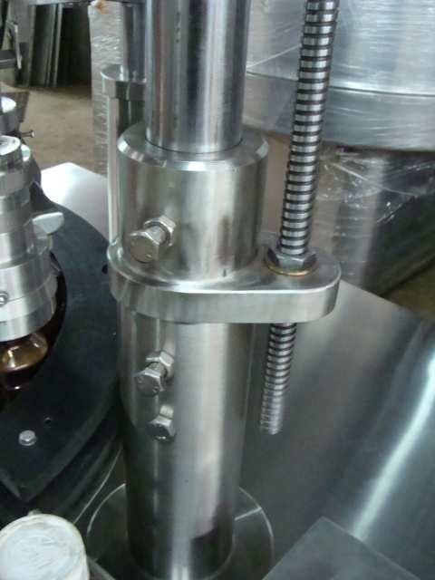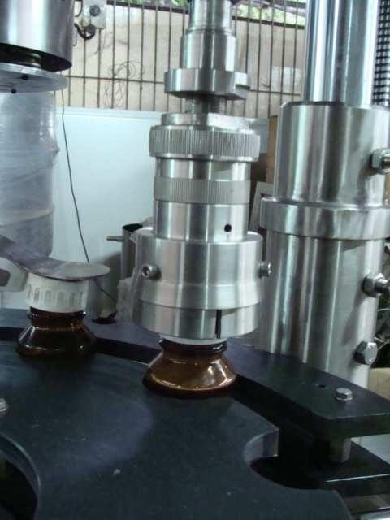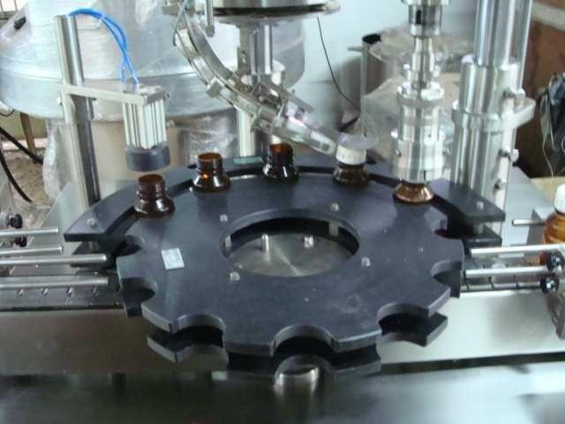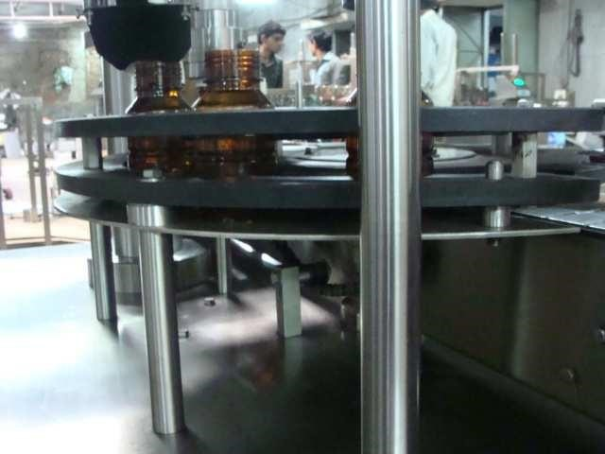
Turn

the

nut

to

take

height

of

capping

head

Loose

the

Two

Bolts

Back

Guide

2

Nos

Bolt

Pin

of

star

wheel

2

nos

pins

of

back

guide

Star

wheel

fixing

3

nos

Bolt

4. Change over of screw Cap

- First of all select the cap size suitable change part i.e. cap bowl strips, chute(if cap die is more difference), and turret
- Set the chute inlet with the bowl outlet so that the cap can move easily from bowl to chute and tight the bolts of chute mounting.
- Now adjust the height of the vibrator by same way as we adjust the capping head height. Set the height of the vibrator such as the 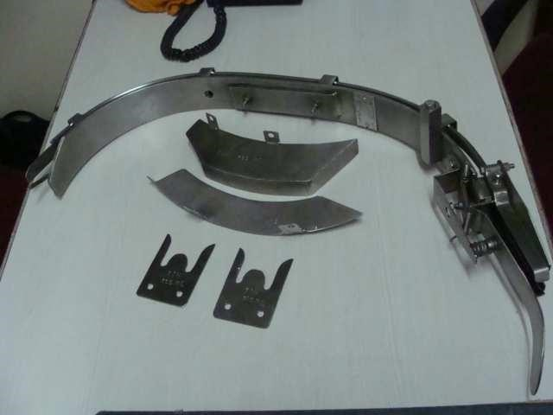bottle can take cap easily from the chute end.
Cap

strip

chute

- Adjust the conveyor side guides according to the bottle dia.

- The hopper unit needs to set for individual caps size. Distance between the Rotary Plate and Ring to be adjusted with the help of four adjusting bolts. Adjust the side guides in chute end as per cap dia.

- Adjust the pressure of screwing head.

- Set the required speed using the built in potentiometer on the A.C. frequency drive for capping head machine vibrator and conveyor.

MACHINE OPERATION
The incoming bottles are transferred by conveyor up to the star plate. As the bottle moves in star wheel and back guide it picks up cap from the chute end. Further, bottle is transferred to center of the screwing head. The screwing head rotates and moves down on to the bottles and gets screwing operation on the bottle and then transferred to the conveyor to further machine.

The vibrator orients the caps and feed them to the chute.

HOW TO SET SCREWING HEAD:-

After adjusting the height of screwing head set the screwing head individually one by one
Screwing head setting to done at screwing area of the machine. Screwing head consist of a three jaws at the end of screwing head which is called turret and the PU Rubber is fitted on the turret according to cap die. Take the desire pressure on the cap of bottle so that turret hold the cap tightly. The torque of head can be settable as per requirement of cap tightness.
The torque can be increased or decreased by setting the distance of magnet housings with the help of threads provided to set the same (see picture)

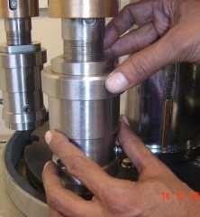

HOW TO SET VIBRATOR BOWL:
1.3Change over for Cap Size
For Cap size change over, Cap feeder (vibrating bowl), Cap chute & Cap Star wheel to be changed according to Cap size.
2.1 Adjustment of vibrator bowl patti, chute and its height

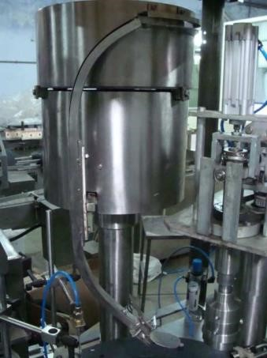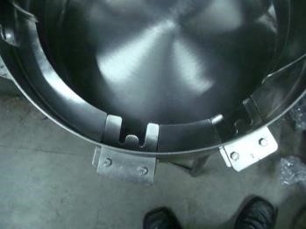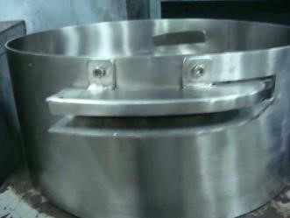
chute

c
B
h
o
u
w
t
e
l

p
att
i

- Select the proper chute and bowl patti according to the cap size.
- Fix the chute as shown in the picture by loosing the two bolts and then tight it.
- Fix the bowl patti according the cap as shown in picture and set it properly.

- Now take the height of the vibrator mounting piller by loosing bolt and turn the hand wheel clockwise or anticlockwise to take up or down the height. See the picture above.

- Now pass the container and check it that container is taking cap properly.

- Now set the chute end that when container pass through the mouth it take only one cap properly. See the picture.
PREVETIVE MAINTANANCE AND CHECK LIST:-

a). Before starting the machine for production the machine should be thoroughly cleaned with cloth.

b). Ensure the oil level of the reduction gearbox at the specified level.

c). Lubricate daily all moving parts with SAE-30 oil and grease as per the requirement

d). Periodically check the drive chains and belt at proper tension.
e).Don’t drop oil on the rubber ‘V’ Belt.
f).Don’t start the machine when pillar – locking bolt of screwing head will be loose.

g).Ensure electrical supply on each phase of the drive before starting the machine.

h). Thoroughly clean the machine after completing the day’s production.

MAINTENANCE
DAILY | - Clean the Machine thoroughly  - Grease the head spindle bushes  - Oil the head roller bushes
WEEKLY | - Grease the Cam  - Tighten the pressure block  - Tighten the roller blocks and roller bushes
MONTHLY | - Greece the Chain, Chain sprockets and gears  - Tighten the screw and nuts
HALF YERLY | 1. Check the oil level in reduction gear boxes
YERLY | 1. Replace the oil in reduction gear boxes

TROUBLE SHOOTING SUGGESTIONS

Problem | Cause / Remedies
1.Cap is damaged | - See the working of turret jaws. And correct it  - Head Pressure on cap is too high. Do it correct  - Torque is too high. decrease the torque
2.Cap is loose | - Head Pressure on cap is too high. Do it correct  - Torque is too low. Increase the torque  - see the working of turret jaws and correct it
3. Jerking of slat conveyor belt. | a. To tight the chain.
4 Improper synchronization of star Platform | a. There are a fault in setting. Pl. set it properly.
5 Machine does not start | a.Check the supply and correct it.  b.MCB in control panel is not ON.  c.clutch indication is on. To reset the indication move the starplate so the clutch indication will off.

DRAWING WITH SPARE PART LIST

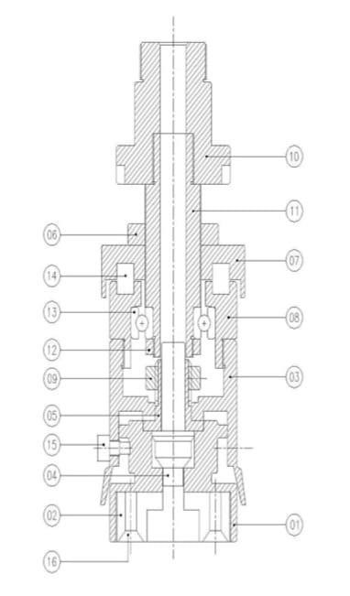
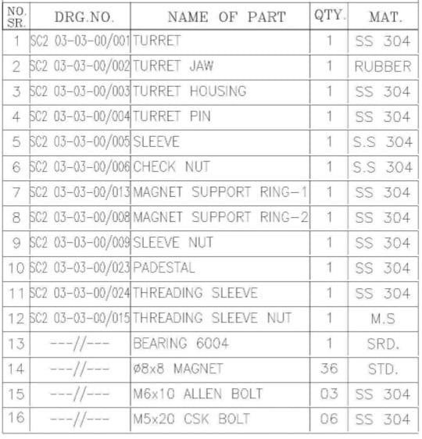

ELECTRIC WIRING DIAGRAM

Programming procedure.
Example:
1. For First speed setting.
- Press PRG key You will find d-00
- Again Press PRG Key,
- You will found digital indication P- 0.00
- To change the contents P-0.00 to P-9.03
- To change the content P-0.00 to P-0.01 Press UP / Down Key then press SET Key
- Set value as per requirement with the help of UP/DOWN key.
- Press SET Key two times to save the setting value and go for other contents. Do the same procedure.
For other setting follow same procedure and use AC drive setting chart.

AC Drive setting table.
No | Display Order | Function name | AC Drive setting Value.
1 | P 0.01 | Main frequency source (External POT) | 4-Speed Varies from  External POT  0-Speed Varies from Drive  Display
2 | P 0.04 | Operating function setting | 1-External Start  0- Start/Stop from drive display
3 | P0.12 | Torque | 10
4 | P0.14 | Acceleration time | 1
5 | P0.15 | Deceleration time | 1
6 | P3.04 | To see the frequency on display | 1
7 | P4.00 | To stop externally i.e. by pushbutton | 15
8 | P4.06 | For pushbutton / selector switch | 2 (3wire)for pushbutton  1 (2wire)for selector switch
9 | P5.06 | Min. Frequency | 10 or 20
10 | P5.07  &  P0.06 | Max. Frequency | 50
11 | P4.02 | Multifunction Input ( Inching or Jog) | 9
12 | P2.19 | Inching or Jog Frequency | 20
13 | P2.20 | Inching or Jog Acceleration Time | 1
14 | P2.21 | Inching or Jog Deceleration Time | 1
15 | P3.02 | Programme Lock or Unlock | 1Lock  2Unlock

Notes
- Refer Instruction manual for more details.
- Follow sequence as per setting chart table.
- To Reset the programme of AC Drive GO P3.01 and put value 1 and then enter the programme as above.

Other products from B N ENTERPRISES

Specialization In Automatic Liquid Packaging & Trunkey Projects.

- Rotary Bottle / Vial Washing Machine
- Automatic Linear Bottle / Vial Washing Machine
- Automatic Volumetric Liquid Filling Machine
- Automatic VISCOFILL Liquid Filling Machine
- Rotary Piston filling cum screwing machine(MONOBLCOCK)
- Automatic Multi Head ROPP / PP Cap Screwing Machine
- Automatic Plastic Cap (Screw) screwing Machine
- Automatic Dozing Cup/Inner Plug placement Machine
- Automatic Self Adhesive (Sticker) Labeling Machine
- Automatic wet glue Labeling Machine
- Online Visual Inspection Conveyor Belt
- Packing Conveyor Belt
- Slat Conveyor Belt
- Turn Table
- Sparkler Type Filter Press
- Transfer Pumps Centrifugal / Gear Type.
- Storage Tanks / Jacketed Tank / Mixing Tank
- Liquid / Ointment / Lotion Manufacturing Plant
- Stirrer / Homogenizer

- Semi Automatic Volumetric Liquid Filling Machine
- Semi Automatic VISCOFILL Liquid Filling Machine
- Semi Automatic ROPP Cap Screwing Machine
- Semi Automatic Plastic (Screw) Cap Screwing Machine
- Cap Elevator/ Loader
- Automatic Carton Coader

CONTACT DETAIL FOR SPARES & SERVICE

Hope you read carefully all contain of this user manual, further if you need any support / technical assistance contact us at our customer support center detail mention below.

B N ENTERPRISES
Gate No.20,Near Khedshivapur
Industrial Estate, Kondhanpur Road, Arvi Village,Pune-412205(MH)India.
Mob No – 8308746511/9607993690
E mail : inf.bnenterprises@gmail.com URL : www.bnenterprises.net

